Health First Colorado, Colorado's Medicaid program

# You may qualify for health coverage no matter what your immigration status is.

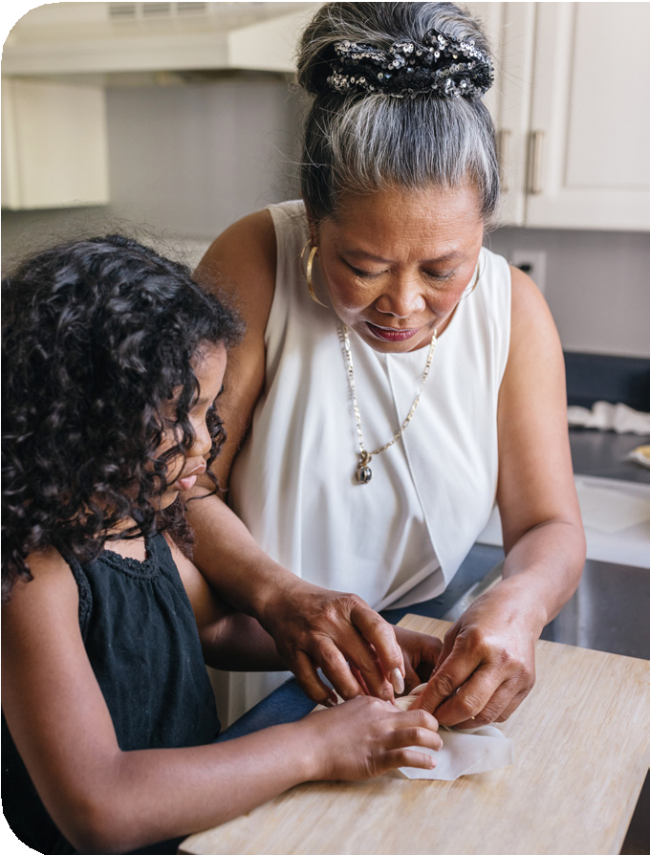A young girl stands at the kitchen counter while she and an older woman with graying hair work together assembling food. 

**NEW!**

**Regardless of your immigration status, if you are pregnant or are 18 years old and younger, you might qualify for full Health First Colorado or Child Health Plan Plus (CHP+) benefits beginning Jan. 1, 2025.**

* Don’t Wait! You might qualify now for some benefits, including family planning, and services necessary to treat an emergency medical condition.
* Your Privacy Matters! The information you give on your application is private. We won’t share it with U.S. Citizenship and Immigration Services or anyone else. Colorado law keeps your personal information safe when you apply for or use most public benefits.



## Apply Now!A young boy and infant girl lay on the ground facing opposite directions, both looking up at the camera and smiling. A young boy and infant girl lay on the ground facing opposite directions, both looking up at the camera and smiling.

Scan the QR code at the left to apply or visit [CO.gov/PEAK](http://co.gov/PEAK)

**Please Download as a Microsoft Word Document to ensure proper formatting**